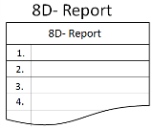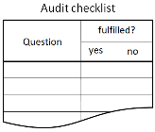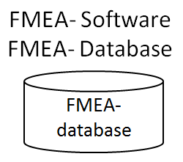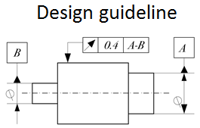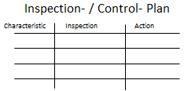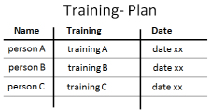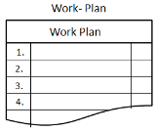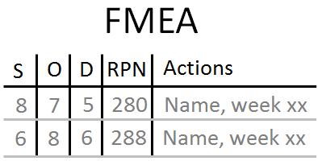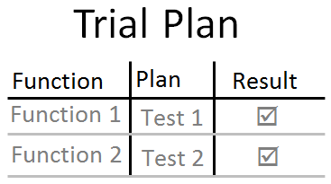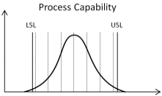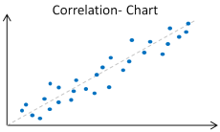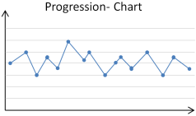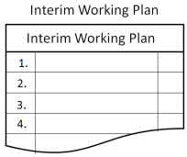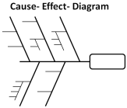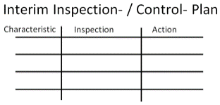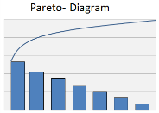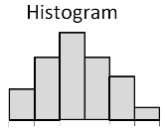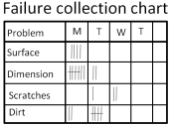S:\03_Excellence\03 02_Supply Chain Quality\03 02 02_Mitarbeiter\Röll\Zeiss Logos\CZ-Logo-klein.gif

* Problem-solving process is formally completed
* Lessons learned will be used for other products / processes
* Corrective actions are sustainably established in the organization
* Effectiveness of corrective action(s) is / are proved
* Root- cause(s) of the problem is/are identified
* Customer (internal / external) is no longer faced with the problem
* Problem is clearly described and confined
* Team composition is defined
* Define team composition (team leader and team members)
* Describe the problem in a precise, comprehensive, complete and confined manner
* Remove defective parts from the total circulation
* Take measures to ensure supply readiness
* Analyse possible root cause(s)
* Analyse and determine cause- effect relationships
* Possible corrective actions to develop, assess and evaluate
* chosen corrective actions to prove and to prove their effectiveness
* establish corrective actions organizationally
* Release containment actions
* Make Lessons learned available for other-, existing- and future products / processes
* Check successful implementation of the agreed measures, worthy team performance and complete problem solving process

**Discipline 8**Project Completion Congratulate your team

**Discipline 7**Action(s) to Prevent   
Recurrence

**Discipline 6**Implemented Corrective Action(s)

**Discipline 5**Chosen Corrective Action(s)

**Discipline 4**Root Cause(s)

**Discipline 3**Containment Action(s)

**Discipline 2**Problem Description

**Discipline 1**  
Team

**8D Roadmap - Instructions**

**Discipline**

**Major tasks**

**Tools**

**Outcomes**

8D Roadmap – instructions & time table Owner: SBI-EQ/Röll 1/2

S:\03_Excellence\03 02_Supply Chain Quality\03 02 02_Mitarbeiter\Röll\Zeiss Logos\CZ-Logo-klein.gif

8D Roadmap – instructions & time table Owner: SBI-EQ/Röll 2/2

Lessons learned will be used for other products / processes and the problem-solving process is formally completed.

Corrective actions are sustainably established in the organization

Problem identified

* Check successful implementation of the agreed measures, worthy team performance and complete problem solving process
* Make Lessons learned available for other-, existing- and future products / processes
* establish corrective actions organizationally
* Release containment actions
* Possible corrective actions to develop, assess and evaluate
* chosen corrective actions to prove and to prove their effectiveness
* Analyse possible root cause(s)
* Analyse and determine cause- effect relationships
* Remove defective parts from the total circulation
* Take measures to ensure supply readiness
* Describe the problem in a precise, comprehensive, complete and confined manner
* Define team composition (team leader and team members)

**Discipline 8**Project Completion Congratulate your team

**Discipline 7**Action(s) to Prevent Recurrence

**Discipline 6**Implemented Corrective Action(s)

**Discipline 5**Chosen Corrective Action(s)

**Discipline 4**Root Cause(s)

**Discipline 3**Containment Action(s)

**Discipline 2**Problem Description

**Discipline 1**Team

**C**

**B**

**✓**

**A**

**A**

**B**

**C**

Effectiveness of corrective action(s) is / are proved

Customer (internal / external) is no longer faced with the problem

**✓**

**Legend for milestones**

**Chronological sequence**

**8D Roadmap – time table of 8 disciplines**

**Disciplines**

**Major tasks**